**KALOF High Risk Missing Persons**

**Susan BEESLEY – 69 yo**

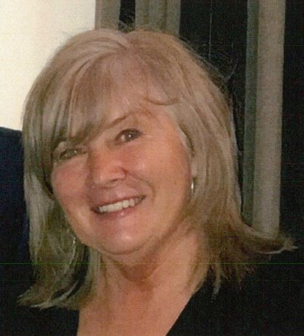

**Guy BEESLEY – 70 yo**

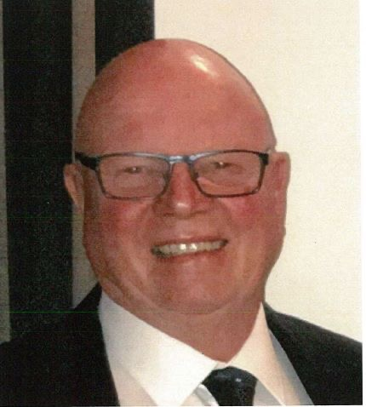

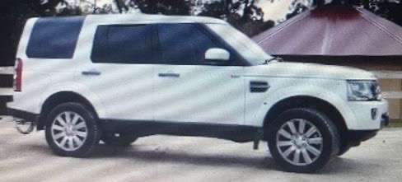

Guy and Susan BEESLEY left the Seymour area at 1200 hours on Monday 28-Oct-2019 in their white 2016 Land Rover Discovery wagon **AJT166** (pictured above), to head home to the Sale area (Gippsland). They mentioned they may go home over the Dinner Plain area.

**The last confirmed sighting of them was in Mansfield at 1530 hours on 28-Oct-2019**.

Guy and Susan would normally make contact with family and have missed an appointment since that time. Police are currently focusing their search in the Jamieson – Licola area.

Any information to Mansfield Police Station 03 57752555.